You´re a native application developer now
This guide covers how to create, build and run a simple “hello world” application using native android tools. It is a brief tutorial that does not go into details of each tool.
- What essential tools you need to know about
- How to create a project and run it on the emulator
- How to set up virtual targets and manage SDKs.
- How to use the debug monitor

Objective

This lab will be executed using the Android command line tool chain, this means that all execution will be done in a terminal window. In Mac you can find a terminal in the Utilities folder, start it and use it for this lab.

The commands executed in this guide can be copied and pasted directly into your terminal window and this is recommended. Note that you need to exclude the C:\ for mac terminal.

Working with development on a command line can be a bit different from working in an IDE, how ever it also makes you understand the underlaying tools in a way that makes your development easier. In this tutorial you will be walked through a few tools in the android tool chain, these are:

- The Android script tool
- The Android virtual manager
- The ant build scripts (debug/release)
- The Android debug bridge
- The Android Emulator

Requirements

- You need to have installed the Android SDK from the android portal
http://developer.android.com/sdk/index.html
- You need to have Apache Ant later than 1.8.0 to be able to use ant for building.
http://ant.apache.org/bindownload.cgi
- Make sure you have added the path for the tools directory so that you don´t have to specify the location each time.

Resources and notes

This guide is an abstraction from developer.android.com and can be studied more in detail at the link provided below, also here is a list of all the links that have been used in the lab:

Android development without IDE
http://developer.android.com/guide/developing/other-ide.html

Android design guidelines and development information can be found at http://developer.android.com/guide/index.html

How to create a new project

In android you create or copy projects by using the android script. When executed with the create project arguments it will create a directory structure that supports the android tool chain. Before you start, create a dedicated folder on your system and name it “Lab”, Lets create the project structure by executing the command line below in the new lab directory:

C:\Lab>android create project --target 6 --name MyAndroidApp --path ./HelloWorldAndroid --activity MyAppActivity --package com.app.myandroid

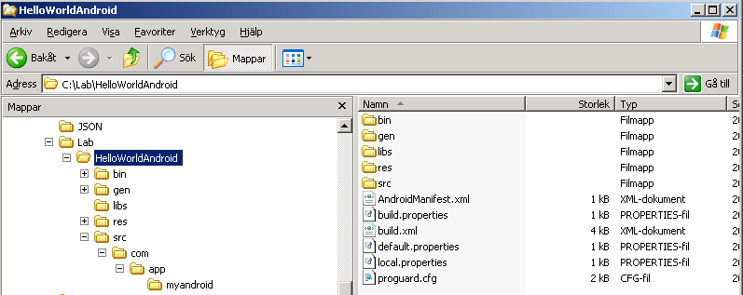

At this point the android ant script have created a number of files and folders that holds the information about this project. Important to notice is the MyAppActivity class down under the /src directory. But also have a look at the xml files that controls the application build process, layout and properties. Be careful not changing these unless you know what you are doing, but do browse the structure so you have seen those files and locations

Caution: You should refrain from moving the location of the SDK directory, because this will break the build scripts. (They will need to be manually updated to reflect the new SDK location before they will work again.)

How to build your new project

At this point you will want to try and build the project this is done with the ant script called debug or release. We will start using the debug because this is also simplest when it comes to signing. Signing the application is done automatically when you build in debug mode. Build your project by issuing this in your project directory:

C:\Lab\HelloWorldAndroid\ant debug

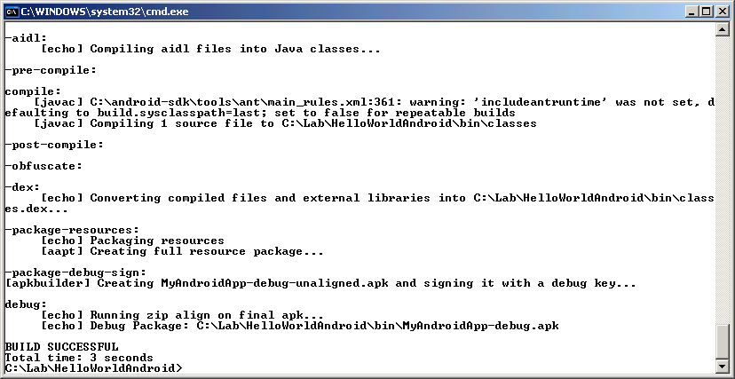

You may notice a few warnings during the build but you should have a BUILD SUCCESSFUL in the end. The warnings can be addressed later.

Caution: You may need to update the Ant tool to handle the latest ant scripts. Go here for the latest Ant tool: http://ant.apache.org/bindownload.cgi and download the ant file to your system. Unzip it into the same ant directory as you had before and edit your environment variable called ANT_HOME to the new directory. Close the command line terminal and restart it to take effect.

Caution: If you will get a debug certificate error like this one: [exec] Debug Certificate expired on 8/4/08 3:43 PM. You may have to locate the debug.keystore file in the ./android directory and remove it first, a new one will be created for you when you run ant debug again.

How to download your new application into the emulator

To be able to run your application with the debugger you need a virtual target device that represents a mobile phone. To do that you need to run the Android SDK and Virtual device manager. You do this by issuing this command:

C:\Lab>android

This will bring up the following user interface. This interface can be used to manage your devices as well as SDK levels installed in your system. The AVD manager is often used in Titanium as well to manage these settings.

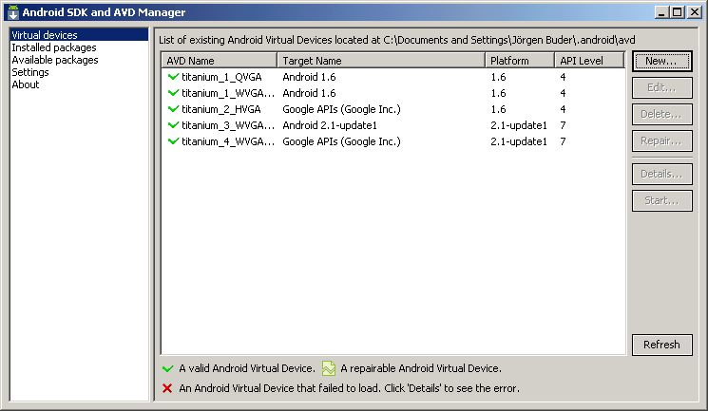

You may or may not already see a number of devices but lets create a new one for your project. Click the new button on the top right. And fill in the new device according to your needs. Remember to use the same or above API level on your device as your application is created for, in this case 8 or more. Here is an example:
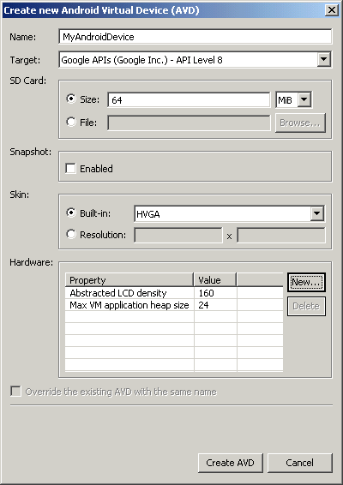
When you are done click the Create AVD button and you will have a new device ready to use for your debugger sessions, it may take a while, be patient. (ref 2 minutes)

Now lets start your application with the android debugger bridge (adb) and tell it that you want to run on your newly created device. From the android virtual device manager you choose the newly created device and click the start button. When asked for additional settings, only click launch button.

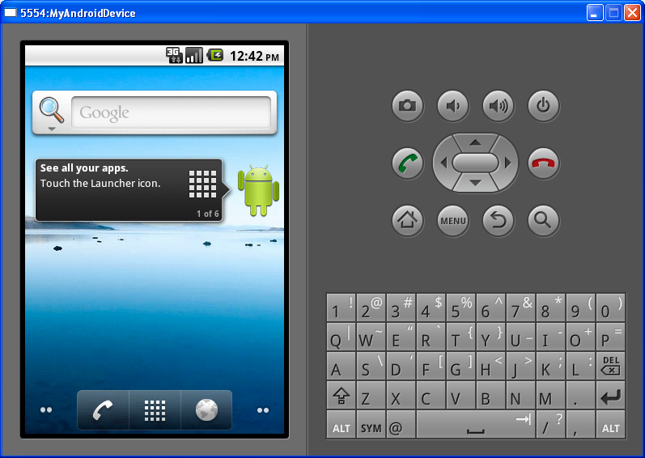
Your actual user interface may look different depending on what target device API you choose. But this device now represents your mobile phone and you can now download and launch applications for testing. Lets download your newly build application to the emulator. Issue the command:

C:\Lab>adb install bin/MyAndroidApp-debug.apk

After successful downloading you may have to start the application by navigating to it in the programs menu of your target mobile phone. In this case found as a MyAppActivity and an android icon. Start it by clicking it and your application should start.

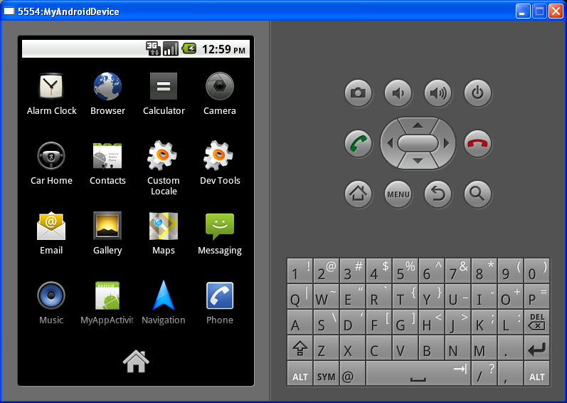

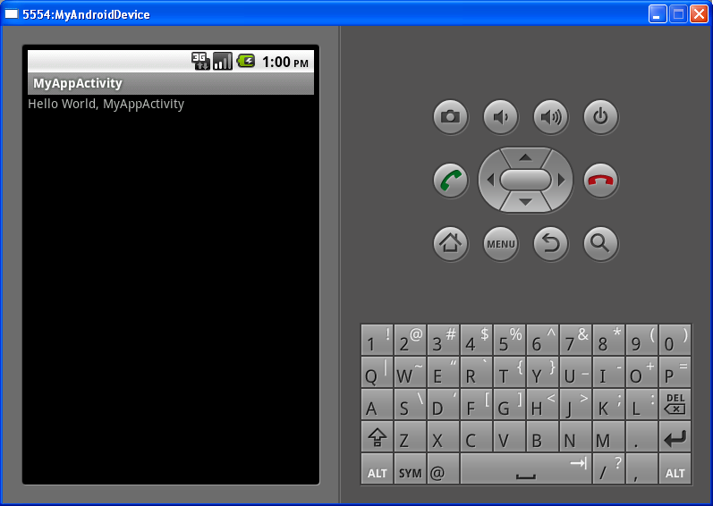
From here you can now go on and start editing your application by bringing up your favorite editor and start writing code. Android design guidelines and development information can be found at http://developer.android.com/guide/index.html

Here is the code in the first activity class of your application. The file is located in :
C:\Lab\HelloWorldAndroid\src\com\app\myandroid\MyAppActivity.java

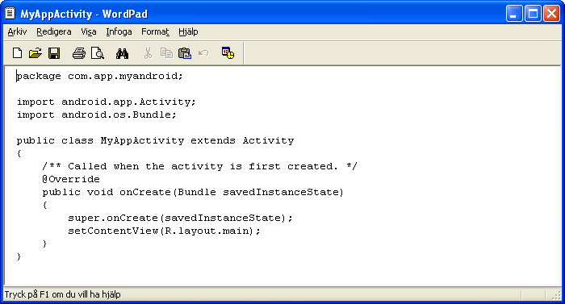
As you can see you do not find the “hello world” string in the class, this is defined in the main layout located in this directory: C:\Lab\HelloWorldAndroid\res\layout\main.xml

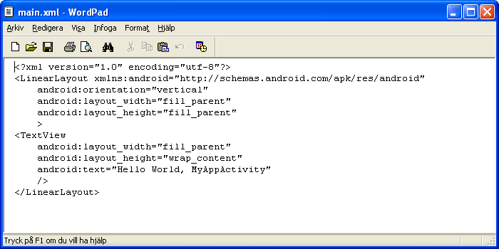
As you would continue to explore the native development of Android you would gradually learn what files controls what and how to design your user interface and code for best practices.

Dalvik Debug Monitor

How ever there is one more thing interesting to investigate before leaving this lab. The ddms tool which gives you access to the application and simulator can make your life easier by presenting you with typical debug information. Issue the command:

C:\Lab>ddms

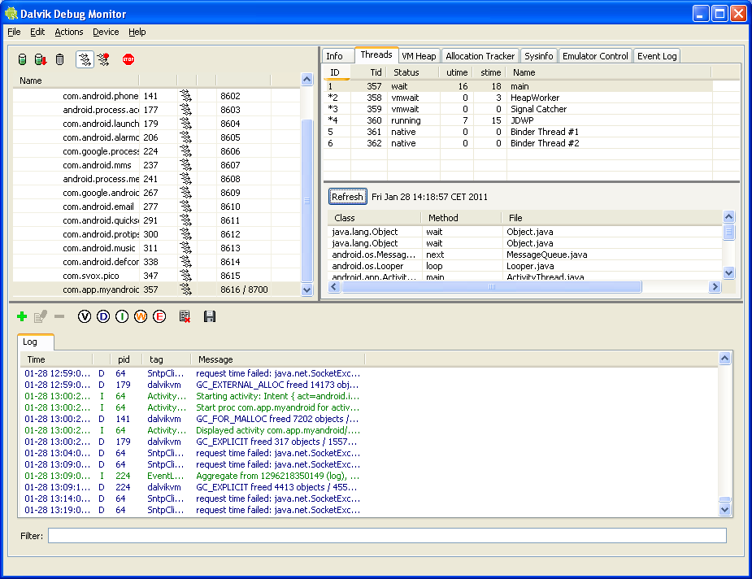
The Dalvik Debug Monitor is your window to the target. You can do things like inspecting your application, view logs, look at threads and depending on your hardware setup simulate things like GPS coordinates or making calls.

You should be able to see your application in the process list as “com.app.myandroid”. Do click it and explore the threads and other debug information you can read about it. You can also stop the process from here if needed.

Summary

You should now have a brief understanding of the underlaying processes of how android application are build. Please reference the android development site for more in depth information.

In this lab you have been introduced to a number of android tools that are critical to the android tool chain. There are a few other tools as well you may need to know about, so here is a list of those and the tools in this lab that you will also find on their site, see link below.

Android Development Tools Plugin (for the Eclipse IDE)
The ADT plugin adds powerful extensions to the Eclipse integrated environment, making creating and debugging your Android applications easier and faster. If you use Eclipse, the ADT plugin gives you an incredible boost in developing Android applications.
Android Emulator
A QEMU-based device-emulation tool that you can use to design, debug, and test your applications in an actual Android run-time environment.
Android Virtual Devices (AVDs)
Virtual device configurations that you create, to model device characteristics in the Android Emulator. In each configuration, you can specify the Android platform to run, the hardware options, and the emulator skin to use. Each AVD functions as an independent device with it's own storage for user data, SD card, and so on.
Hierarchy Viewer
The Hierarchy Viewer tool allows you to debug and optimize your user interface. It provides a visual representation of your layout's hierarchy of Views and a magnified inspector of the current display with a pixel grid, so you can get your layout just right.
layoutopt
This tool lets you quickly analyze your application's layouts for efficiency.
Draw 9-patch
The Draw 9-patch tool allows you to easily create a NinePatch graphic using a WYSIWYG editor. It also previews stretched versions of the image, and highlights the area in which content is allowed.
Dalvik Debug Monitor Service (ddms)
Integrated with Dalvik, the Android platform's custom VM, this tool lets you manage processes on an emulator or device and assists in debugging. You can use it to kill processes, select a specific process to debug, generate trace data, view heap and thread information, take screenshots of the emulator or device, and more.
Android Debug Bridge (adb)
The adb tool lets you install your application's .apk files on an emulator or device and access the emulator or device from a command line. You can also use it to link a standard debugger to application code running on an Android emulator or device.
This is located in <sdk>/platform-tools/.
Android Asset Packaging Tool (aapt)
The aapt tool lets you create .apk files containing the binaries and resources of Android applications.
Android Interface Description Language (aidl)
Lets you generate code for an interprocess interface, such as what a service might use.

sqlite3
Included as a convenience, this tool lets you access the SQLite data files created and used by Android applications.
Traceview
This tool produces graphical analysis views of trace log data that you can generate from your Android application.
mksdcard
Helps you create a disk image that you can use with the emulator, to simulate the presence of an external storage card (such as an SD card).
dx
The dx tool rewrites .class bytecode into Android bytecode (stored in .dex files.)
UI/Application Exerciser Monkey
The Monkey is a program that runs on your emulator or device and generates pseudo-random streams of user events such as clicks, touches, or gestures, as well as a number of system- level events. You can use the Monkey to stress-test applications that you are developing, in a random yet repeatable manner.
monkeyrunner
The monkeyrunner tool provides an API for writing Python programs that control an Android device or emulator from outside of Android code.
android
A script that lets you manage AVDs and generate Ant build files that you can use to compile your Android applications.
zipalign
An important .apk optimization tool. This tool ensures that all uncompressed data starts with a particular alignment relative to the start of the file. This should always be used to align .apk files after they have been signed.
Notes

Portions of this page are reproduced from work created and shared by the Android Open Source Project and used according to terms described in the Creative Commons 2.5 Attribution License.

Tools overview can be found here:
http://developer.android.com/guide/developing/tools/index.html

